

**Difference between User Interface and User Experience**

**Worksheet 9.1**

**Match the synonym of the vocabulary words, put the numbers in the brakes.**

|  |  |
| --- | --- |
| Vocabulary word | synonym |
| 1.useful | Band (together) (11) |
| 2.findable | Costumer (4) |
| 3.desirable | Utile (1) |
| 4.interface | Job/ duty (7) |
| 5.user | Smaller |
| 6.End users | Locatable (2) |
| 7.tasks | Design (10) |
| 8.Lower- level | Object (5) |
| 9.avoid | Consumer (6) |
| 10.layouts | Stay away from (9) |
| 11.widget | popular (3) |

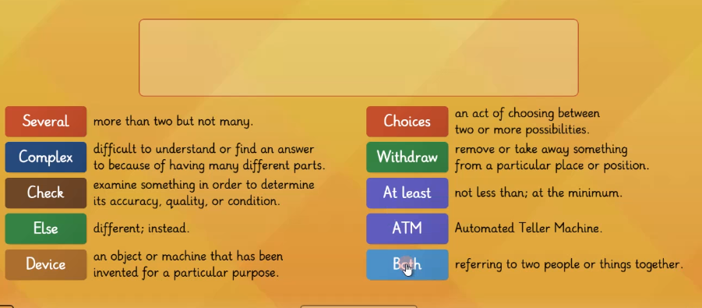

**Worksheet 9.2**

**Reading strategy**

**Watch the video and take some notes if it is necessary.**

[**https://youtu.be/uU0v8eFO53g**](https://youtu.be/uU0v8eFO53g)

[**https://www.youtube.com/watch?v=lQqd7x_6GwE**](https://www.youtube.com/watch?v=lQqd7x_6GwE)

**Read the following text then, you have to create a graphic organizers to summarize the information from the text.**

**Understanding the difference between UI and UX**

**User Interface (UI)**

User **interface** modeling is a development technique used by computer application programmers. Today's **user** interfaces (UIs) are complex software components, which play an essential role in the usability of an application. The term “user interface modeling” is mostly used in an [information technology](https://en.wikipedia.org/wiki/Information_technology) (IT) context. A [user interface](https://en.wikipedia.org/wiki/User_interface) [model](https://en.wikipedia.org/wiki/Model_(abstract)) is a representation of how the **end users** interact with a computer program and how the system responds.

Modeling user interfaces is an independent discipline. For example, modeling techniques can describe interaction objects, **tasks**, and **lower-level** dialogs in user interfaces. Using models as part of user interface development can help understand user requirements, **avoid** premature decisions about specific **layouts** and **widgets**, and make the relationships between different parts of an interface’s and their roles explicit.

**User Experience (UX)**

User experience (UX) is the internal experience that a person has when they interact with every aspect of a company’s products and services. User experience, or UX, appeared as a result of the **improvements** to UI. ‘User experience’ includes all aspects of the end-user’s interaction with the company, its services, and its products. To understand what makes an experience a good one, a great visual was created to specify what goes into effective UX design.

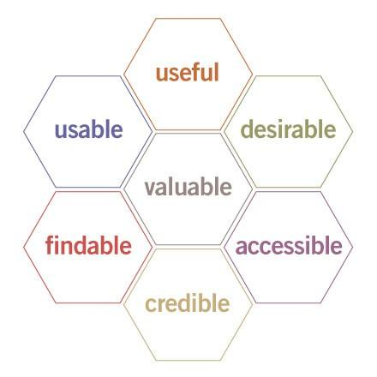

*Usability Honeycomb*

*Source: Peter Moreville*

This ‘usability honeycomb’ is foundation for best practices for UX professionals. UX designers have the responsibility to guarantee that the company creates a product or service that gives a positive UX. UX designers work closely with UI designers.

**Worksheet 9.3**

**Wrap-up**

1. **Work with the three question in a  Jamboard or Padlet tool.**

* What is User Interface? is a development technique used by computer application programmers

* What is User Experience? is the internal experience that a person has when they interact with every aspect of a company’s products and services

* What makes UX great? designers have the responsibility to guarantee that the company creates a product or service that gives a positive

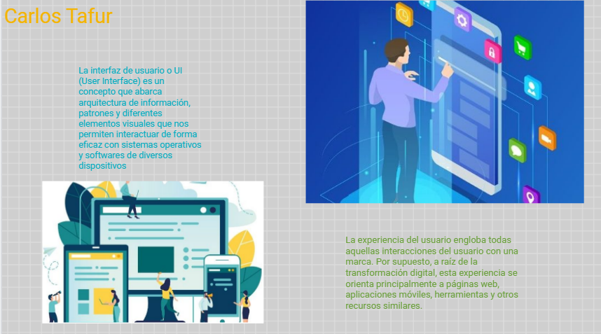

1. **Practice more in this link. Copy and paste the result**

<https://wordwall.net/resource/17062349>

**Self-Evaluation**

**Answer the following questions.**

1. Entiendo la diferencia entre UI y UX.  
   Si No Tal vez
2. Entiendo cómo utilizar un organizador gráfico para hacer un resumen de un texto.  
   Si No Tal vez
3. Usar un organizador gráfico me ayuda a entender y recordar la información de un texto mejor.  
   Si No Tal vez